SV-DPI note:
+ IMPORTANT: Stupid DPI-C : Remember to add the new line character (“\n”) when using printf() in C code. Otherwise it will not print in SV simulation.
+ Try using const as input parameter for import C function to not changing the source value → which is easier to debug later:
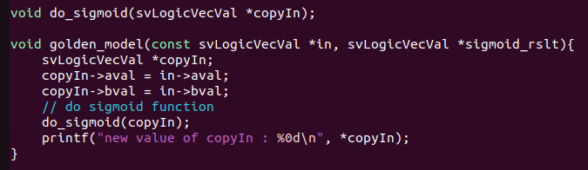

+ make a pointer instead of normal variable when want to passing them to a function. (no need to create a tmp var to store the value of the parameter and the function need no return value – Basic C bruh)

+ Carefull about using the >> and / operator (shift right and divide) on svLogicVecVal datatype:
shift right shift and remove the most right bits corresponding to the amount of shift.
Ie: 11011100 >> 4 = 1101 (lost 4 right bits)
111011 >> 2 = 1110 (lost 2 right bits)
→ need to insert signed bit to the left equal to the amount of shift
→ same problem applied to the divide operator (/ operator)
* Shift left is okay
+ svLeft, svRight:
- return datatype: int
- function: return left/right bound of unpacked array
ie: logic kek[7:2] → svLeft(kek, 1) = 7, svRight(kek, 1) = 2
+ svGetPartselLogic:
- return datatype: void
- copy part of source array to destination array
ie: logic [7:0] src = 8’b1110_0011
logic [3:0] dest;
svGetPartselLogic(dest, src, 4, 4)
→ dest = 1100
+ svPutPartselLogic:
- return datatype: void
- set part of source array to destination array
ie: logic [7:0] src = 8’b1110
logic [3:0] dest = 8’b1110;
svPutPartselLogic(dest, *src, 4, 4)
→ dest = 1100_1110

ie: logic [7:0] src = 8’b1110
logic [3:0] dest = 8’b1110;
svPutPartselLogic(dest, *src, 6, 4)
→ dest = 1100_00_1110 (2 bits 0 is in the middle auto insert)

+ Export function from SV to C:
How: https://github.com/hant225/DPI_Tutorial/blob/main/slides/03_DPI_c2sv.pdf
summmery:
+ run “xelab -dpiheader dpiheader.h”
+run xsc C file with generated “dpiheader.h”
+copy dpi.so file to xsim folder

* IMPORTANT: remember to include the generated “dpiheader.h” file from “xelab -dpiheader dpiheader.h” to C code:

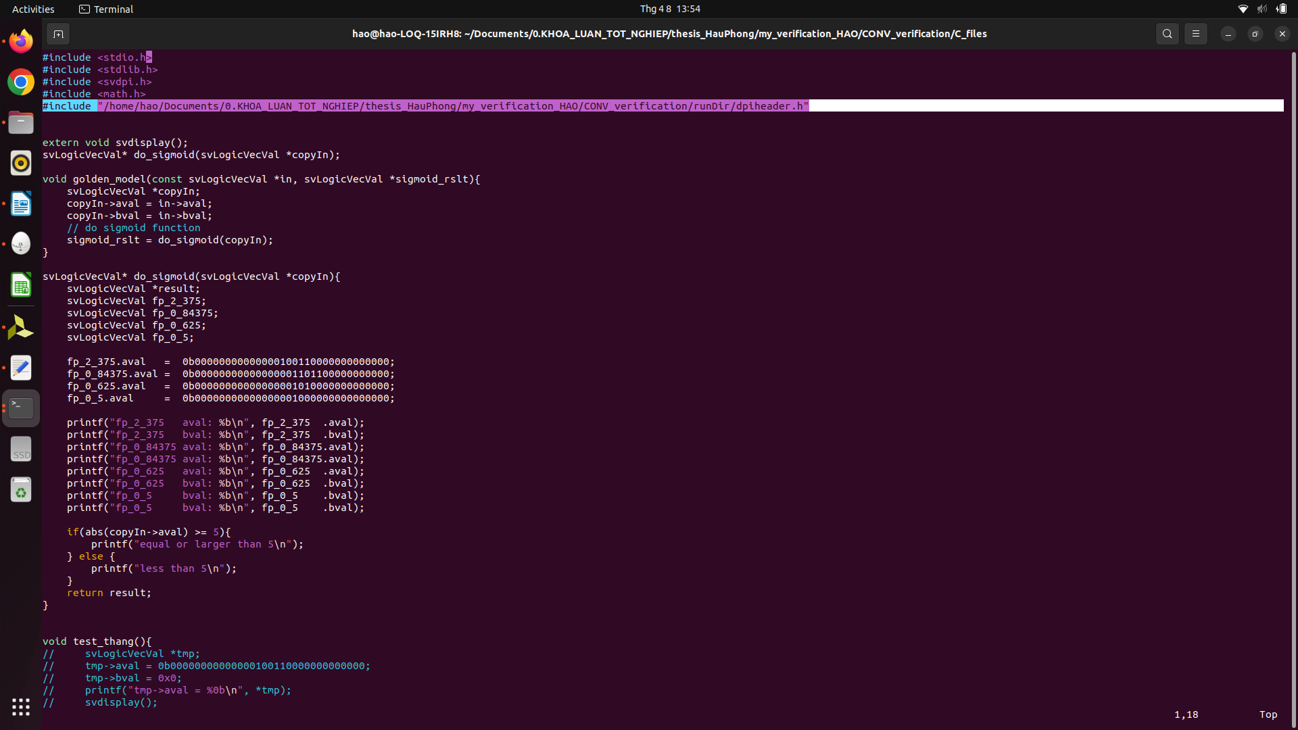

+ Issues with svLogicVecVal pointer:
1. Issues with Export SV to C:
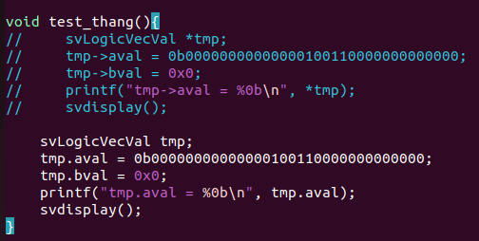
- using pointer: the comment lines catch execption when running (dunno why tho)
- not using pointer: result is okay
2. same as above, issue when declare pointer of svLogicVecVal inside C function:
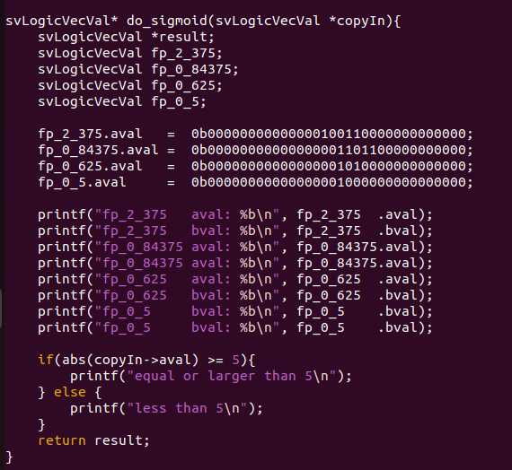

if declare fp_2_375, fp_0_84375, fp_0_625, fp_0_5 as pointers → catch exception when run in vivado).

→ in above situations, it got no error when compile the C file using xsc. Only got exeception when start running the simulation in vivado.

